[appuals.com](https://appuals.com/how-to-fix-the-application-specific-permission-settings-do-not-grant-local-activation-permission-for-the-com-server-application-error/)

# How to Fix 'The Application-Specific Permission Settings do not Grant Local Activation Permission for the COM Server Application' Error - Appuals.com

Kevin Arrows

5-6 minutes

Windows 10 is the latest and the greatest operating system by Microsoft and the company has been pushing users to upgrade from the previous ones quite openly. It makes sense as well as there are several improvements in it over its predecessors. However, quite recently, a lot of reports have been coming in of “DistributedCOM(DCOM) Errors Event ID:10016” Errors in the system logs.

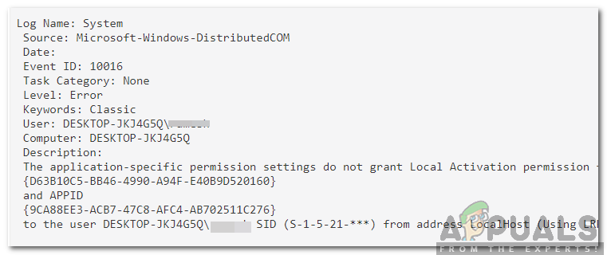

These Errors are quite common and there are many different error logs for them depending on the error. In this article, we will be focusing on the “The Application-Specific Permission Settings Do not Grant Local Activation Permission for the COM Server Application with CLSID {} and APPID {} to the User NT AUTHORITY\LOCAL SERVICE SID () from address LocalHost (Using LRPC) running in the application container Unavailable SID (Unavailable). This security permission Can Be Modified using the Component Services Administrative Tool” Error message.

### What Causes the “The Application-Specific Permission Settings Do not Grant Local Activation Permission” Error?

After receiving numerous reports from multiple users, we decided to investigate the issue and devised a solution to fix it completely. Also, we looked into the reason due to which this error is triggered and listed it below:

[/tie_list type="plus"]

* Invalid Permissions: The Error occurs when a specific process doesn’t have enough permissions to access the DCOM components that are indicated in the event log.

[/tie_list]

Note: It is possible that the system functions correctly in some cases despite this error. If that is the case, it is best to let the error be but if it is preventing a certain application from functioning correctly, follow the guide below:

### Solution: Granting Access to DCOM Components

As indicated in the error message, the error is triggered when certain processes/application don’t have access to the DCOM components. Therefore, in this step, we will be granting access to those DCOM components. For that:

1. Press “Windows” + “R” keys to open the Run prompt.
2. Type in “Regedit” and press “Enter”.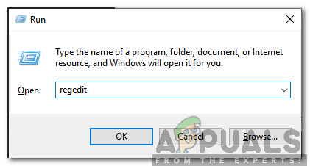
3. Navigate to the following address.

HKEY_CLASSES_ROOT\CLSID\{D63B10C5-BB46-4990-A94F-E40B9D520160}

1. Double click on the “Default” key in the right pane and note down the “Value Data” listed.
2. Navigate to the following address:

HKEY_CLASSES_ROOT\AppID\{9CA88EE3-ACB7-47C8-AFC4-AB702511C276}

1. Right-click on the “{9CA88EE3-ACB7-47c8-AFC4-AB702511C276}” key in the left pane.
2. Click on the “Permissions” option from the list and select “Advanced“.
3. Click on the “Change” option next to the “Owner” heading.  
   Note: The owner should be “Trusted Installer” or it might show “Cannot Display Owner”.
4. Click on the “Object Type” heading and select “Users”.
5. Click on the “Location” button and select your “Desktop(Name)”.
6. In the blank space, enter the username of your account.
7. Click on the “OK” button and click on “Apply” in the window.

Note: Repeat the process indicated in the steps 5-12 for “HKEY_CLASSES_ROOT\CLSID\{D63B10C5-BB46-4990-A94F-E40B9D520160}” as well.

1. Click on “OK” to close the window and open the “Permissions” window that we launched in the “Step 7”.
2. Click on “Administrators” in the “Group or User names” heading and check the “Full Control” option.
3. Select “Users” and check the “Full Control” option again.
4. Click on “Apply” to save the changes and select “OK” to close the window.
5. Press “Windows” + “R” to open the Run prompt.
6. Type in “dcomcnfg.exe” and press “Enter“.
7. Expand the following options

Component Services>Computers>My Computer>DCOM Config

1. In the right pane, right click on the “RunTime Broker” option and select the “Properties” button from the list.  
   Note: There are two instances of the “RunTime Broker” listed in the list. Follow the step below for each one to identify the right one.
2. If the AppID listed there matches with the AppID “9CA88EE3-ACB7-47C8–AFC4–AB702511C276” in the error it means that you have selected the right instance of the application.
3. Click on the “Security” option and then check the “Customize” option for “Launch and Activation Permissions“.
4. Click on the “Edit” button and click on the “Remove” button if there is a “Windows Security” prompt.
5. Click on the “Add” button and type in “NT AUTHORITY\LOCAL SERVICE” in the “Enter The objects Name to select” option.  
   Note: If NT Authority\Local Service isn’t present, try just typing in “Local Service”.
6. Click on “OK” and grand the “Local Activation” permission to the entry.
7. Check to see if the issue persists.